***SEMINAR HALL***

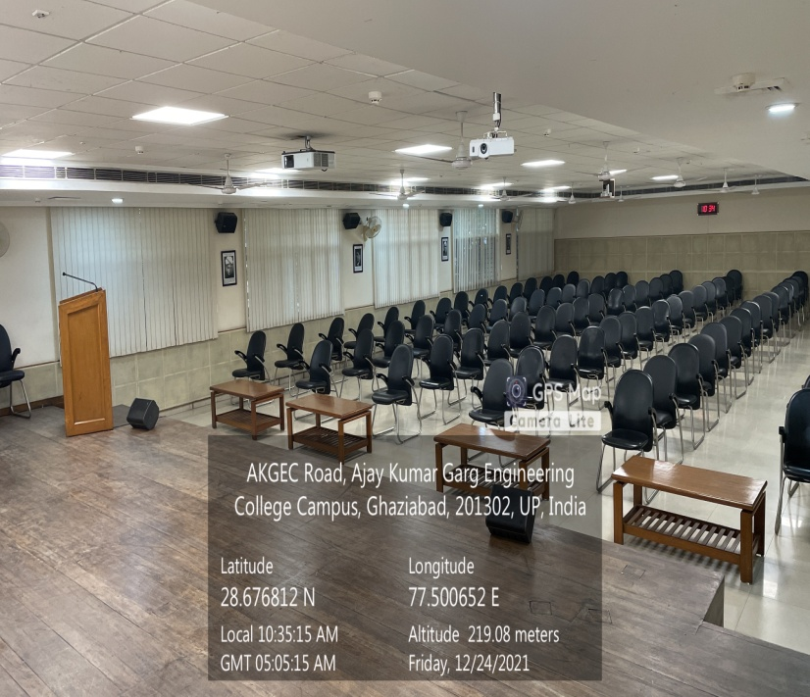

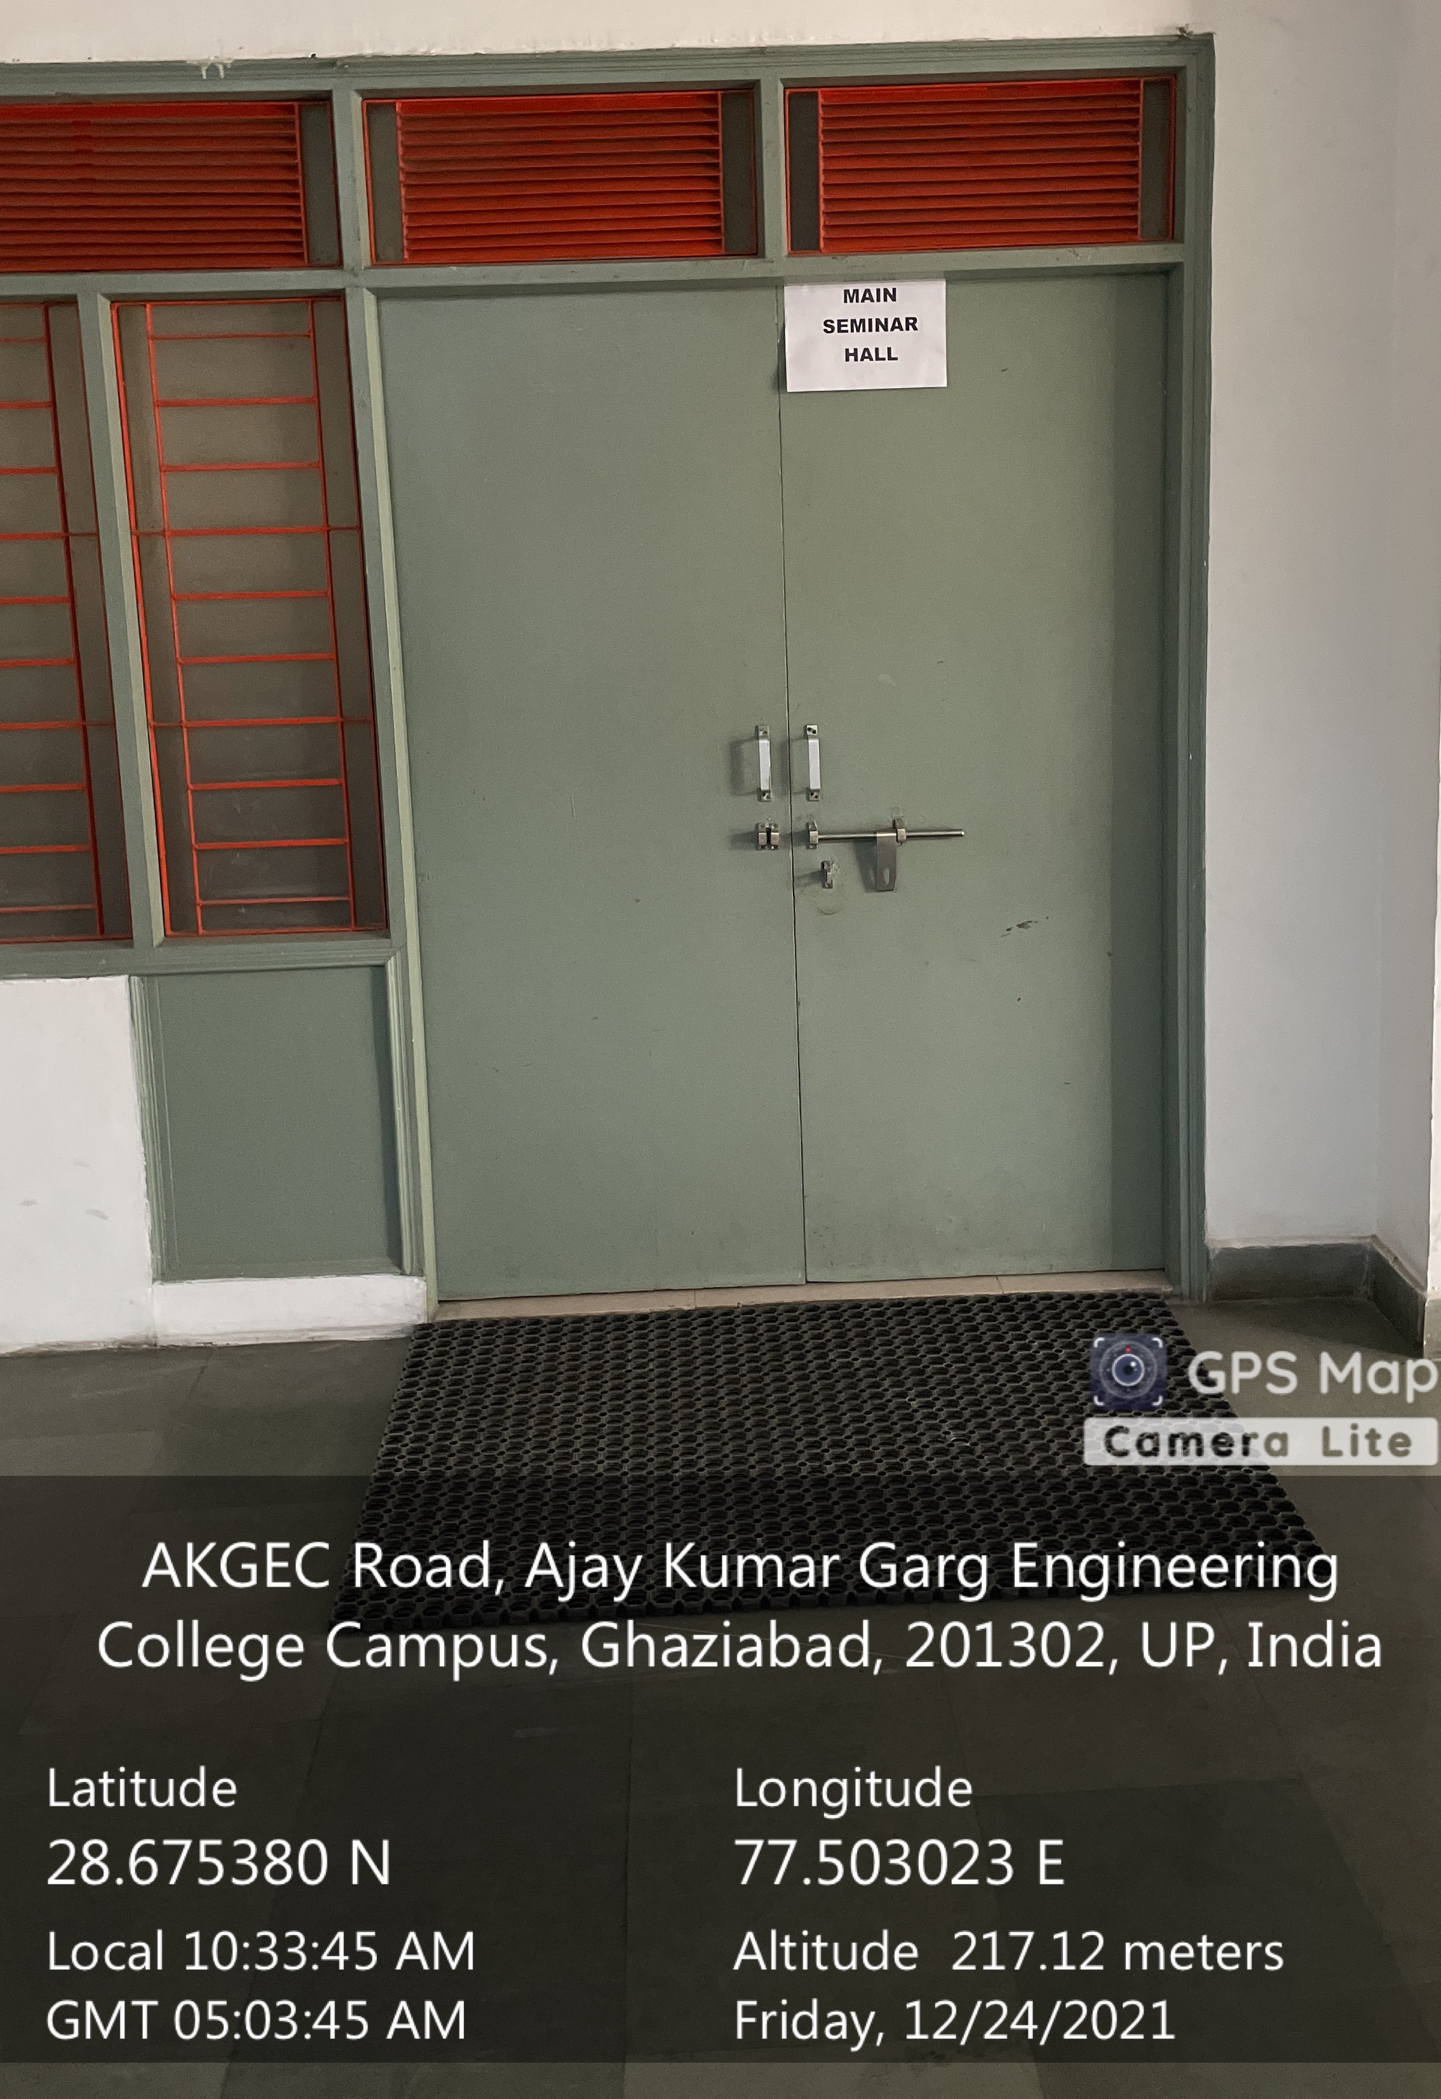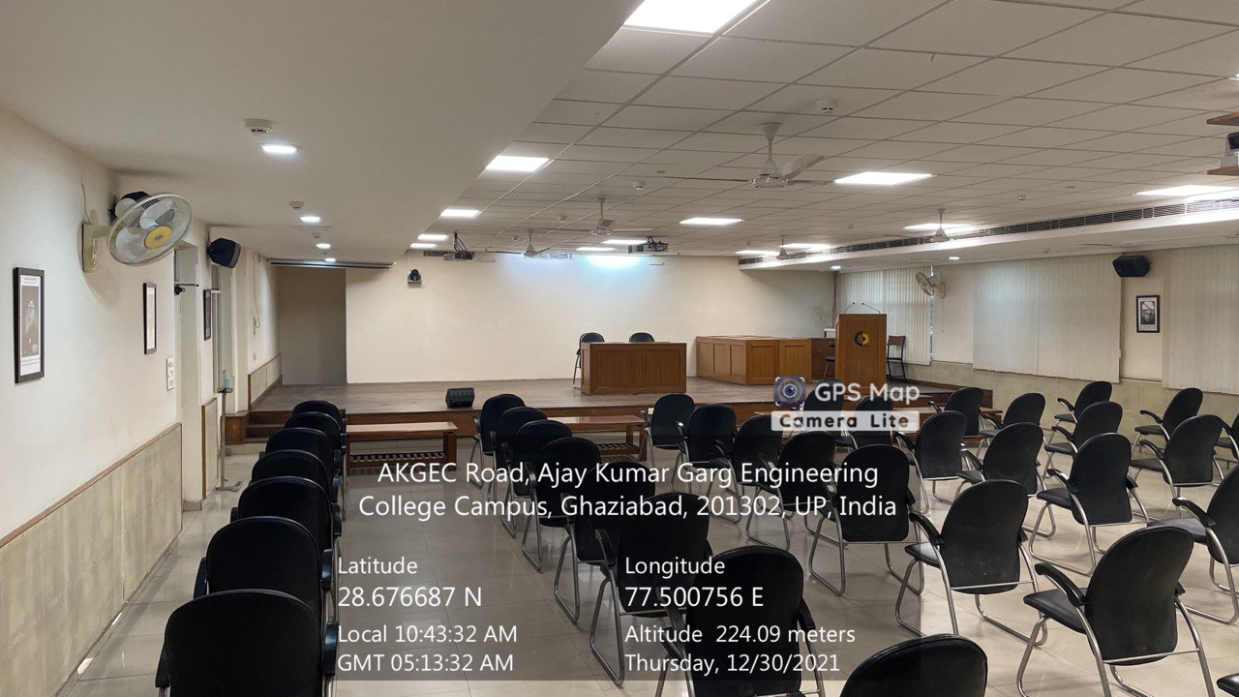

Main Seminar Hall

(ADMINISTRATIVE BLOCK, Second Floor)

Facilities: (Smart Board, Sound System, Wi-Fi, LAN, White Board)

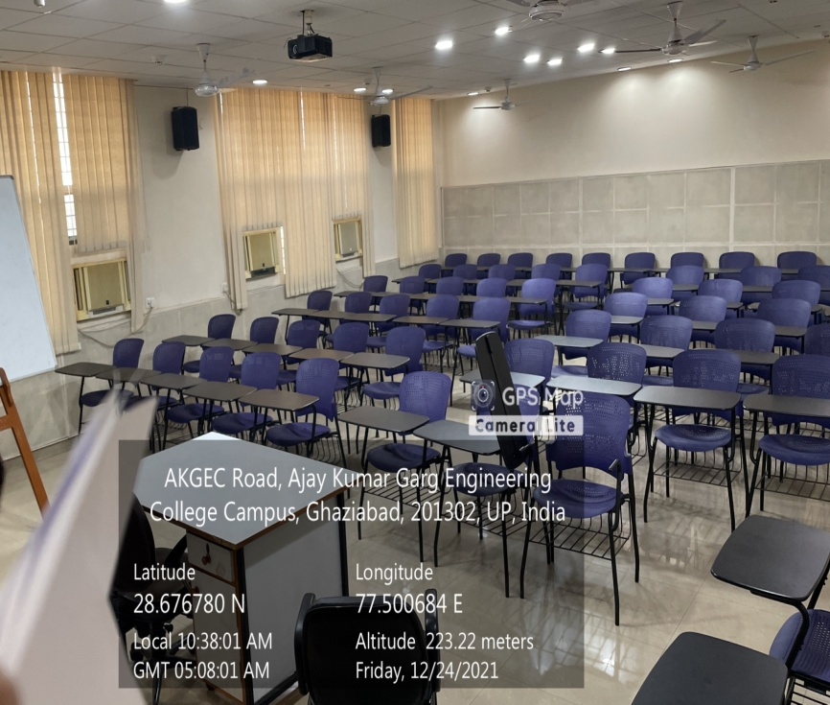

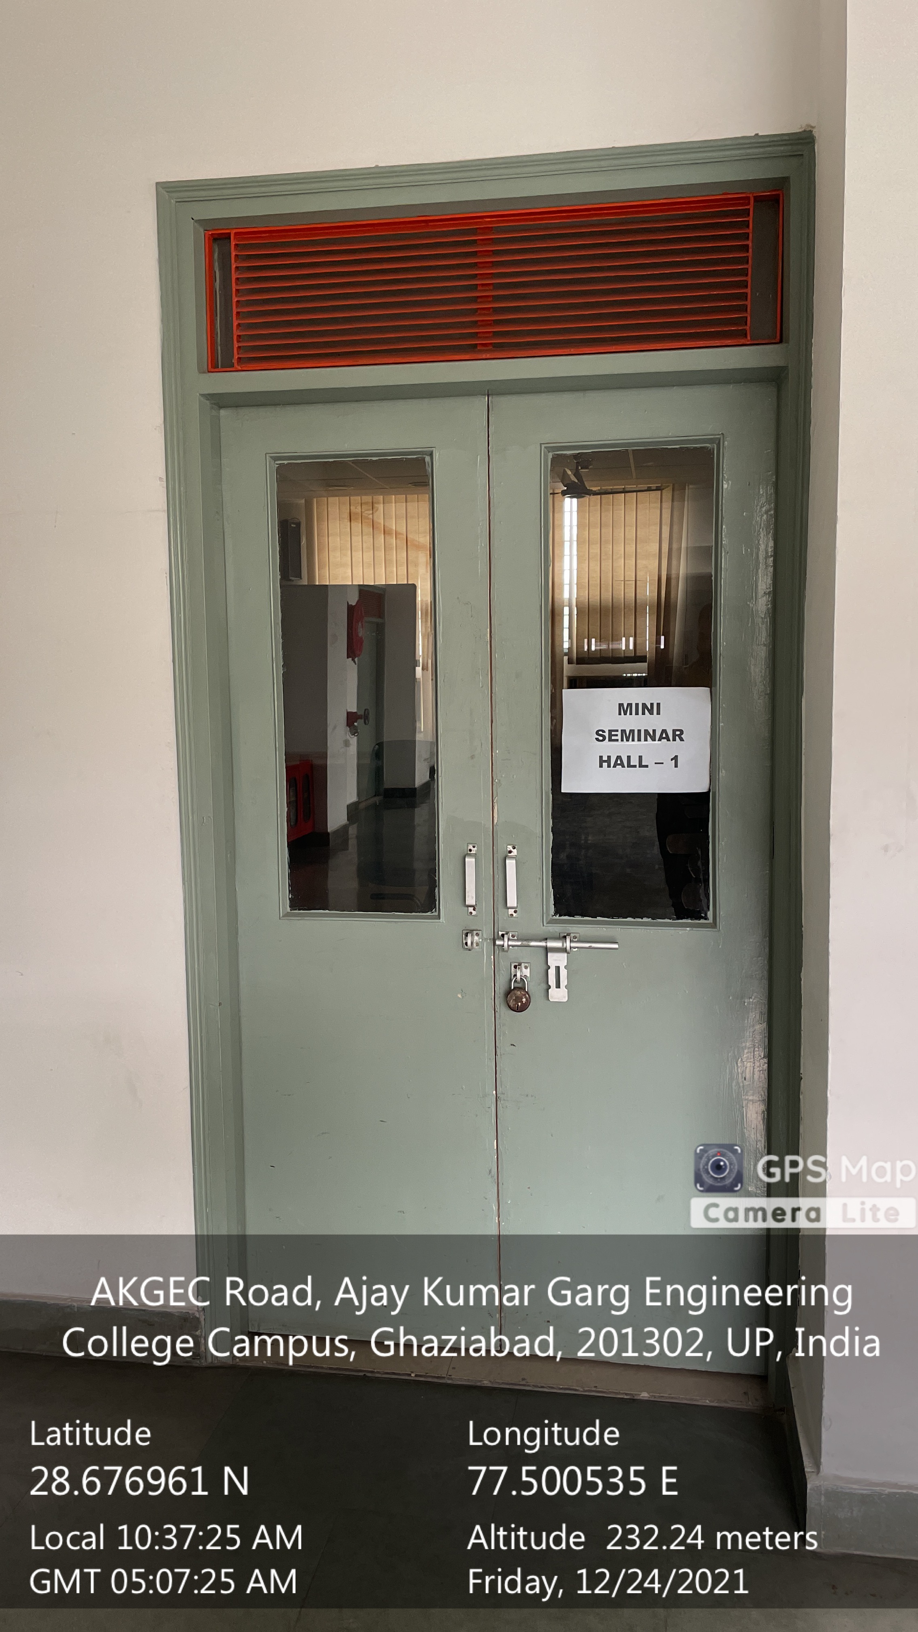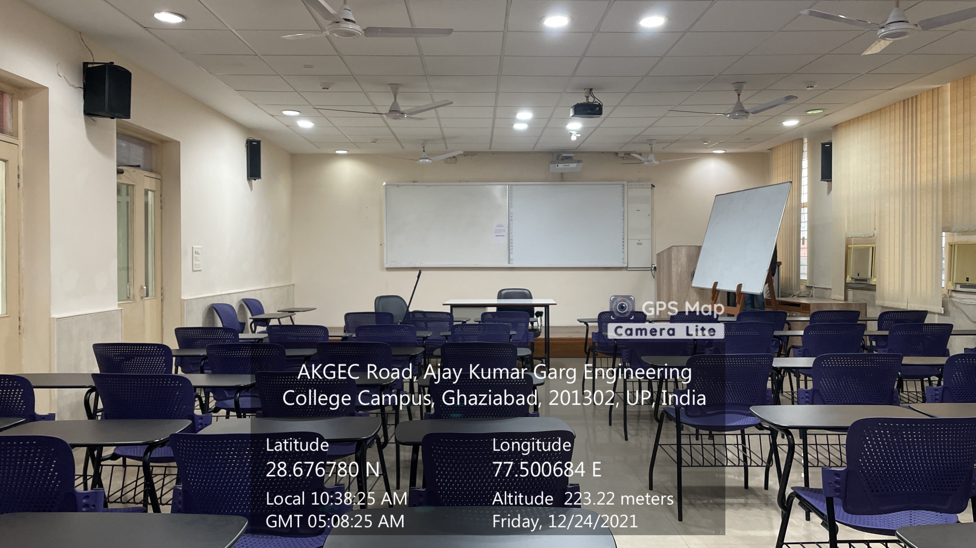

Mini Seminar Hall - 1

(ADMINISTRATIVE BLOCK, Second Floor)

Facilities: (Smart Board, Sound System, Wi-Fi, LAN, White Board)

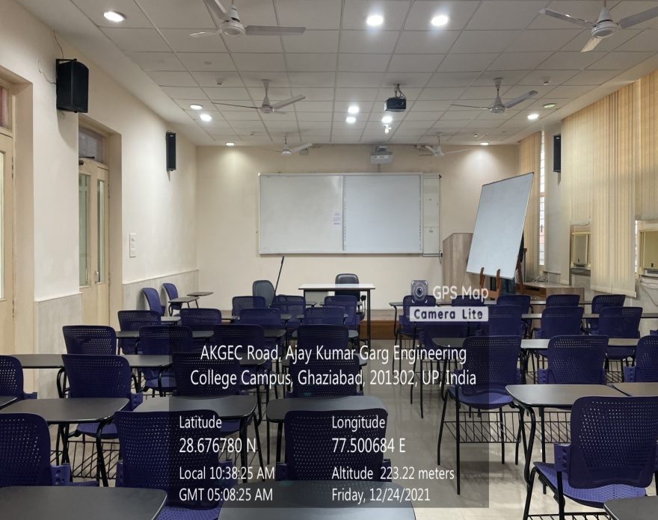

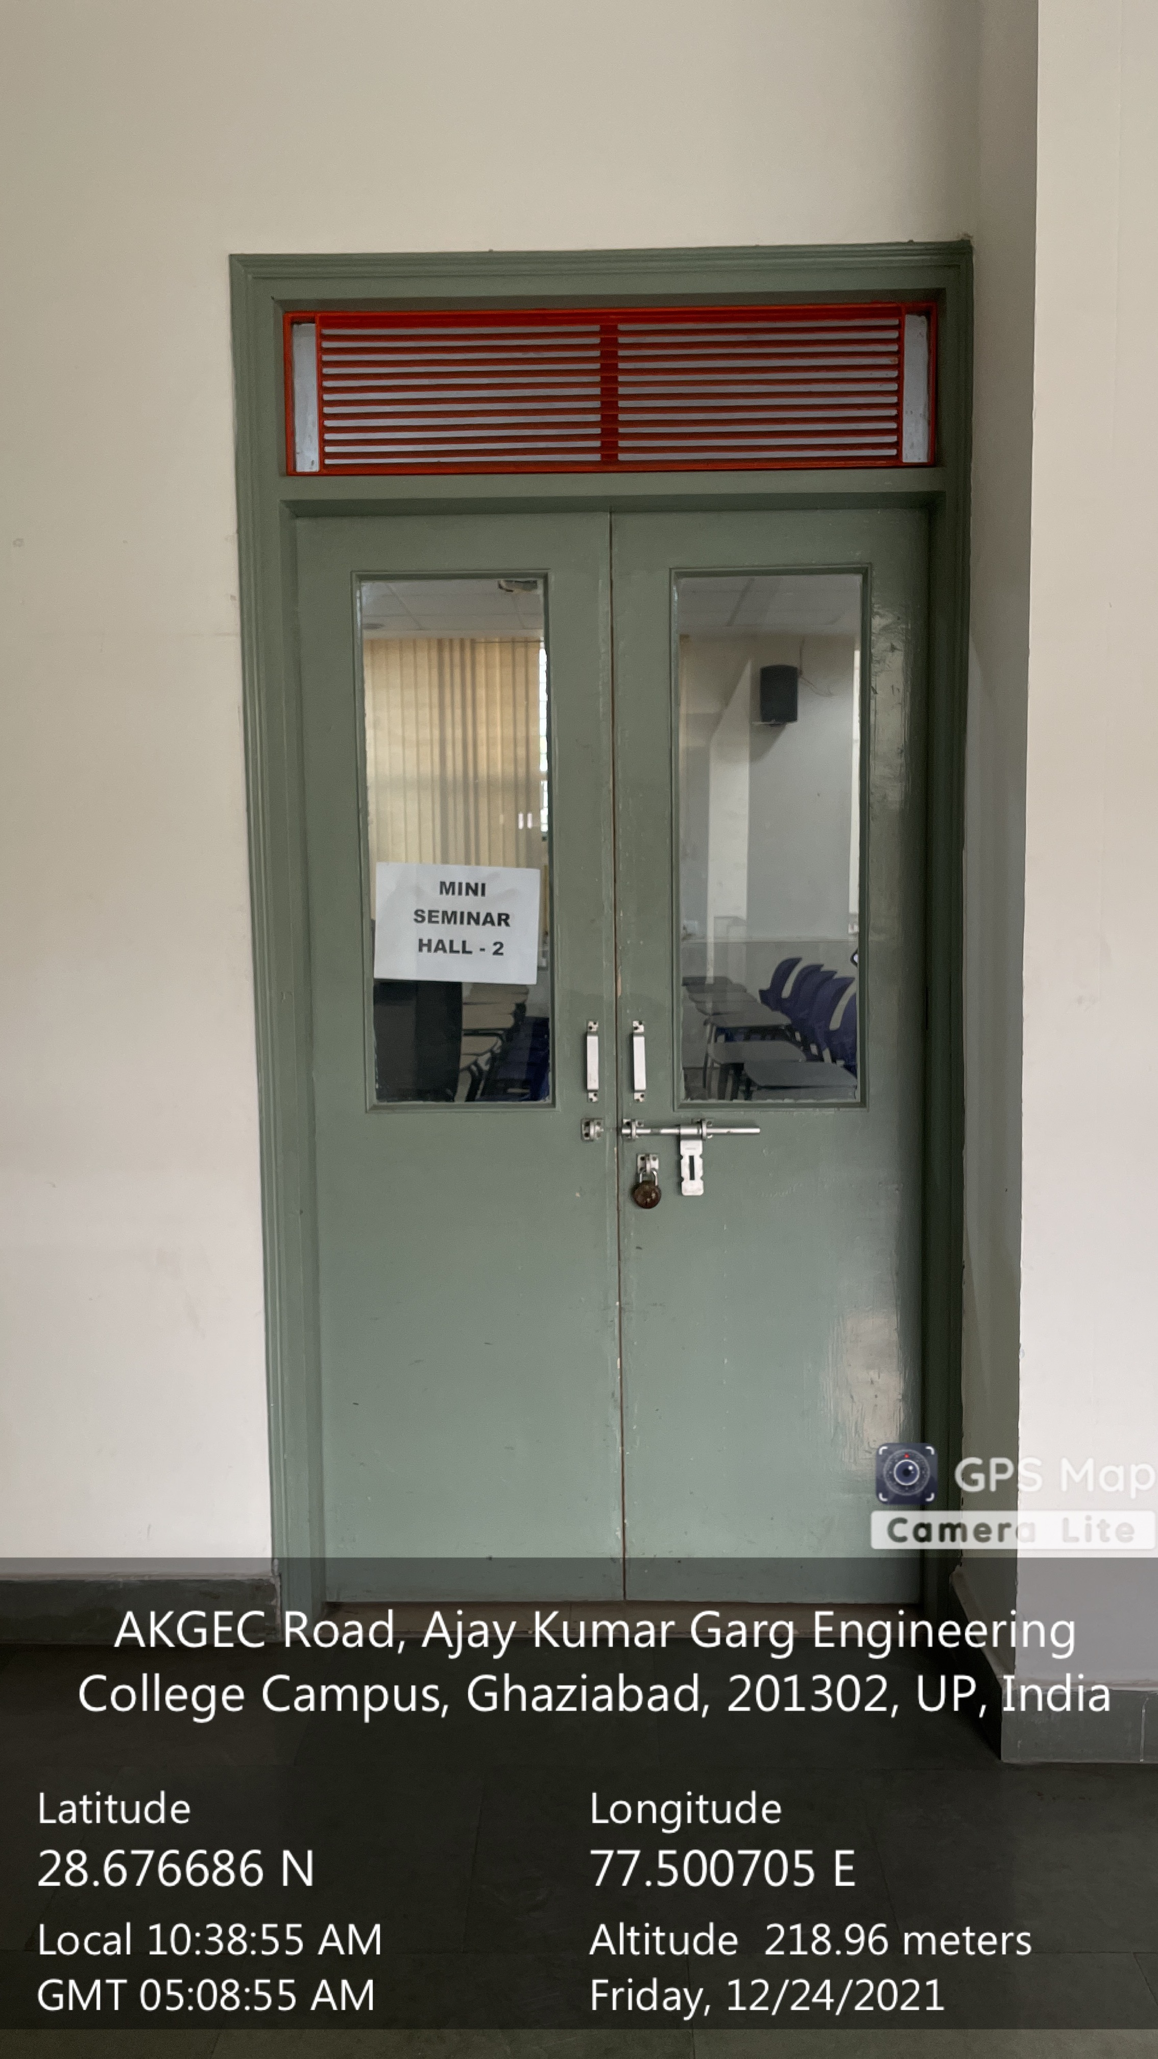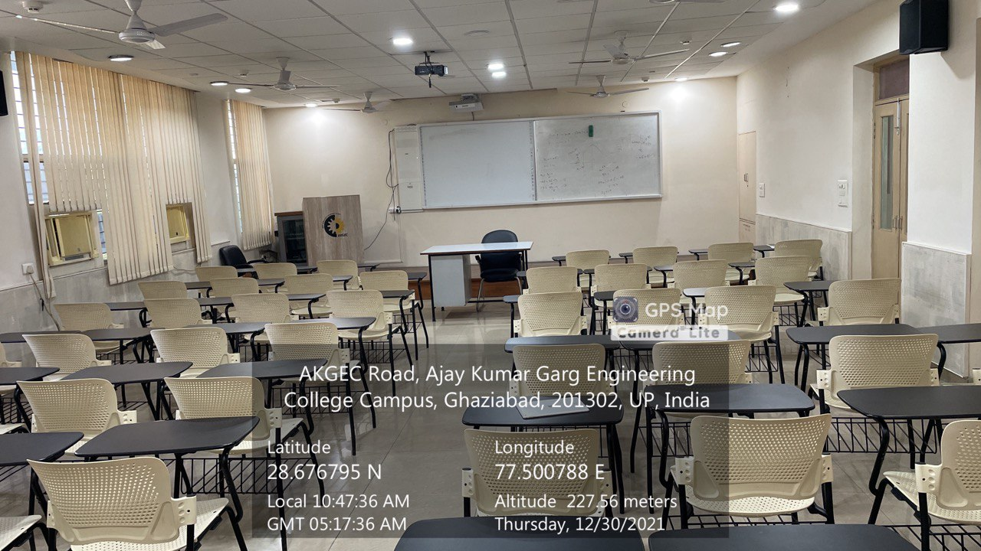

Mini Seminar Hall - 2

(ADMINISTRATIVE BLOCK, Second Floor)

Facilities: (Smart Board, Sound System, Wi-Fi, LAN, White Board)

***CONFERENCE ROOM***

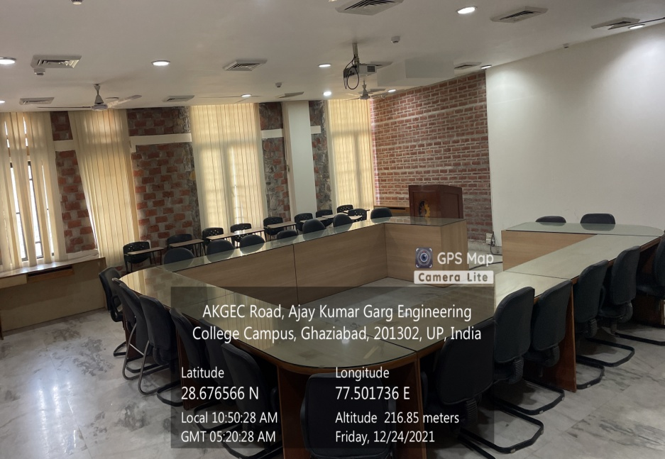

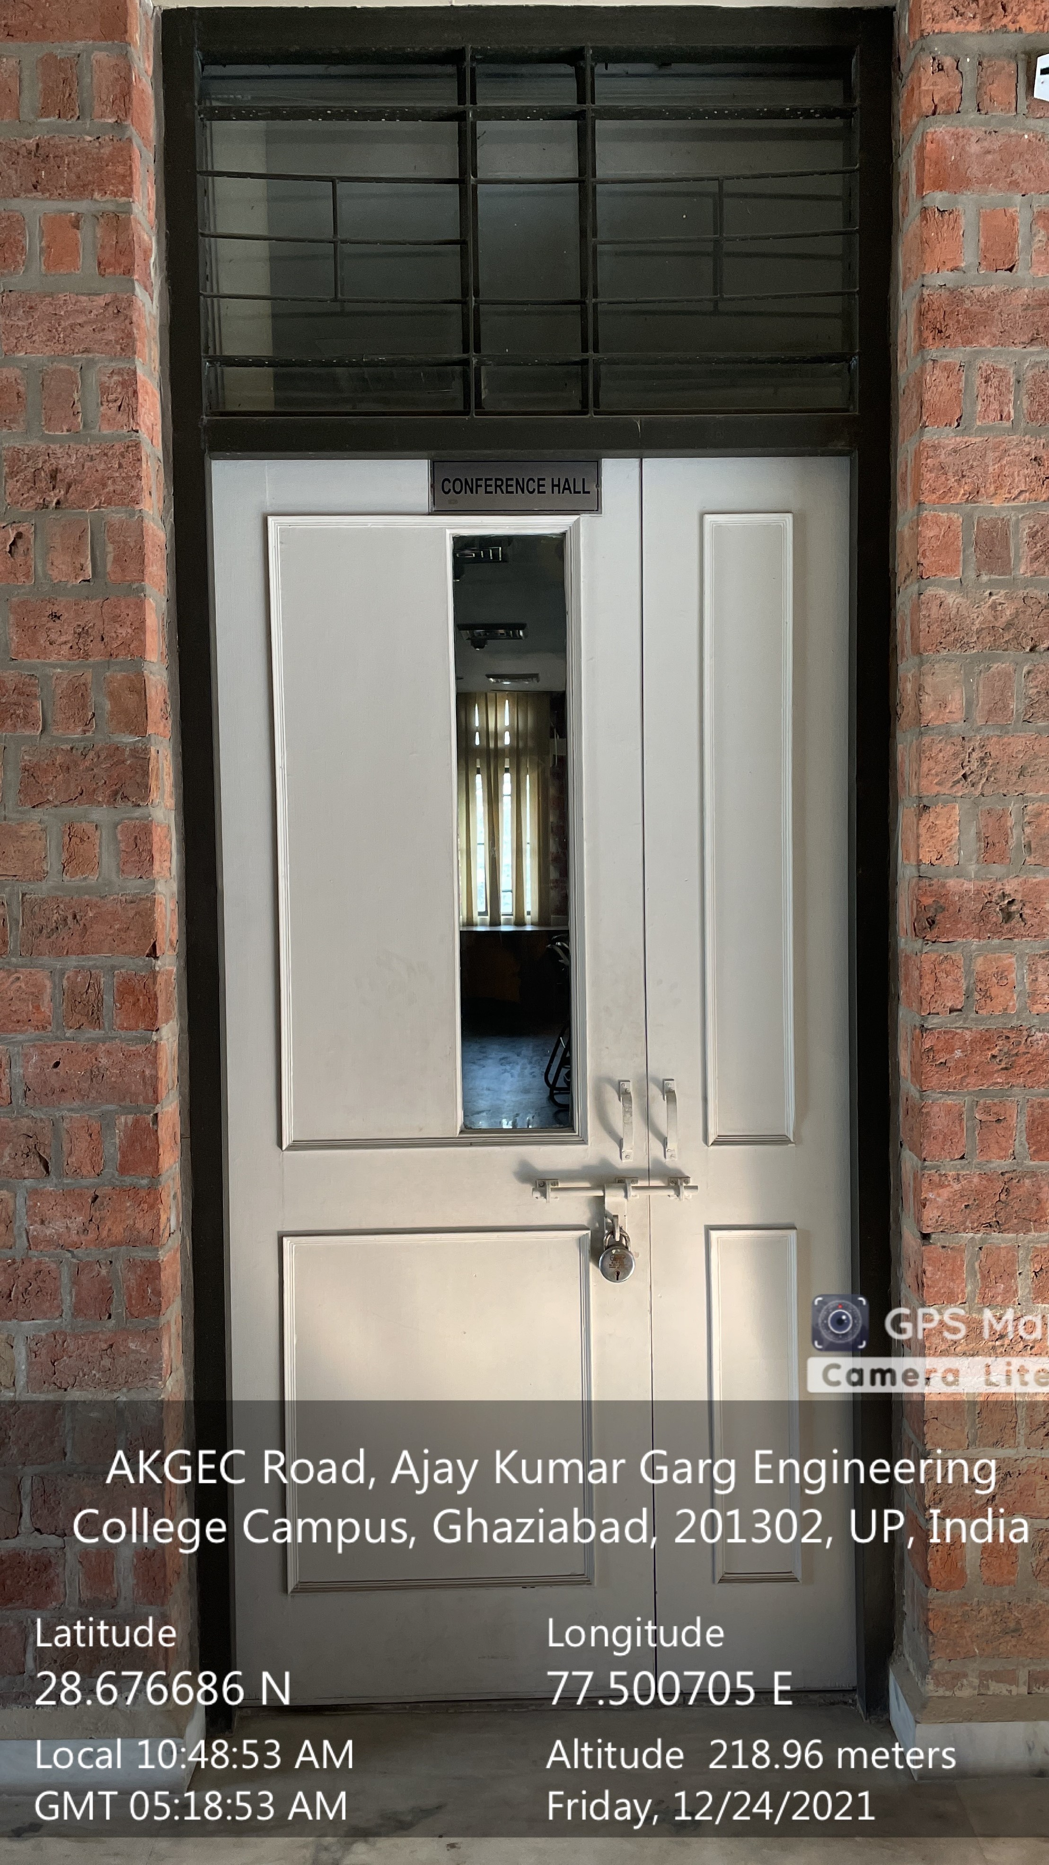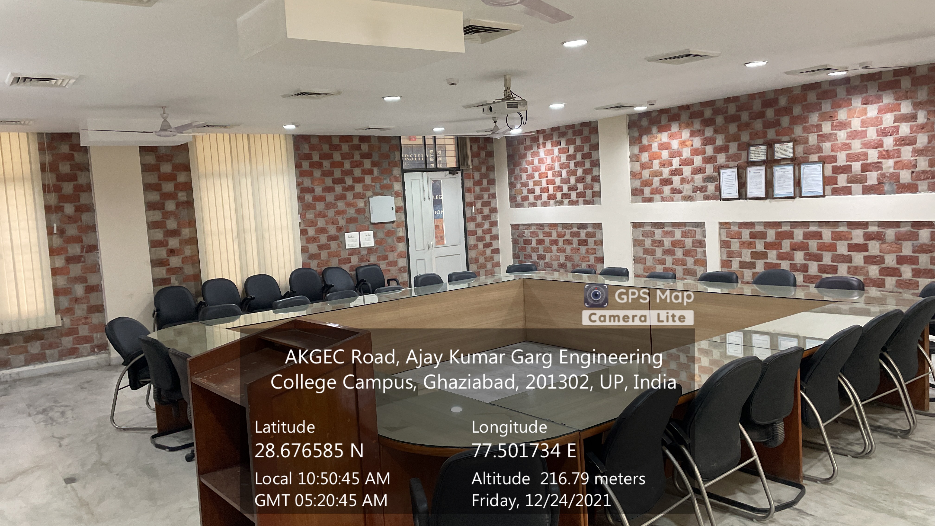

ME Conference Room

(ME BLOCK, First Floor)

Facilities: (Smart Board, Sound System, Wi-Fi, LAN, White Board)

**AUDITORIUM**

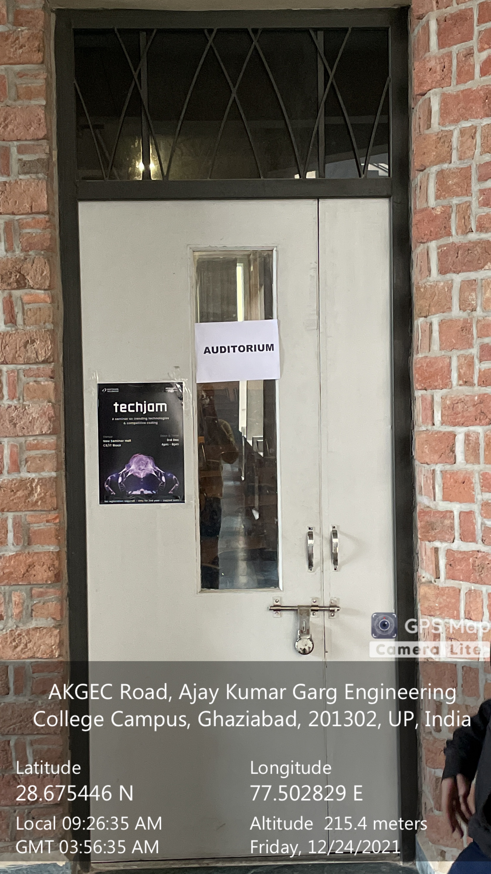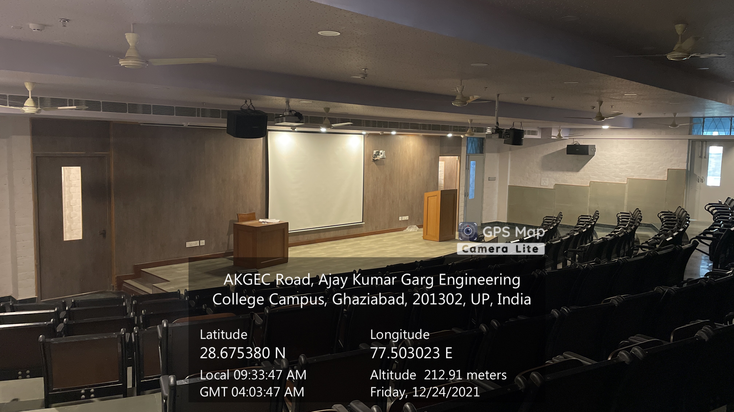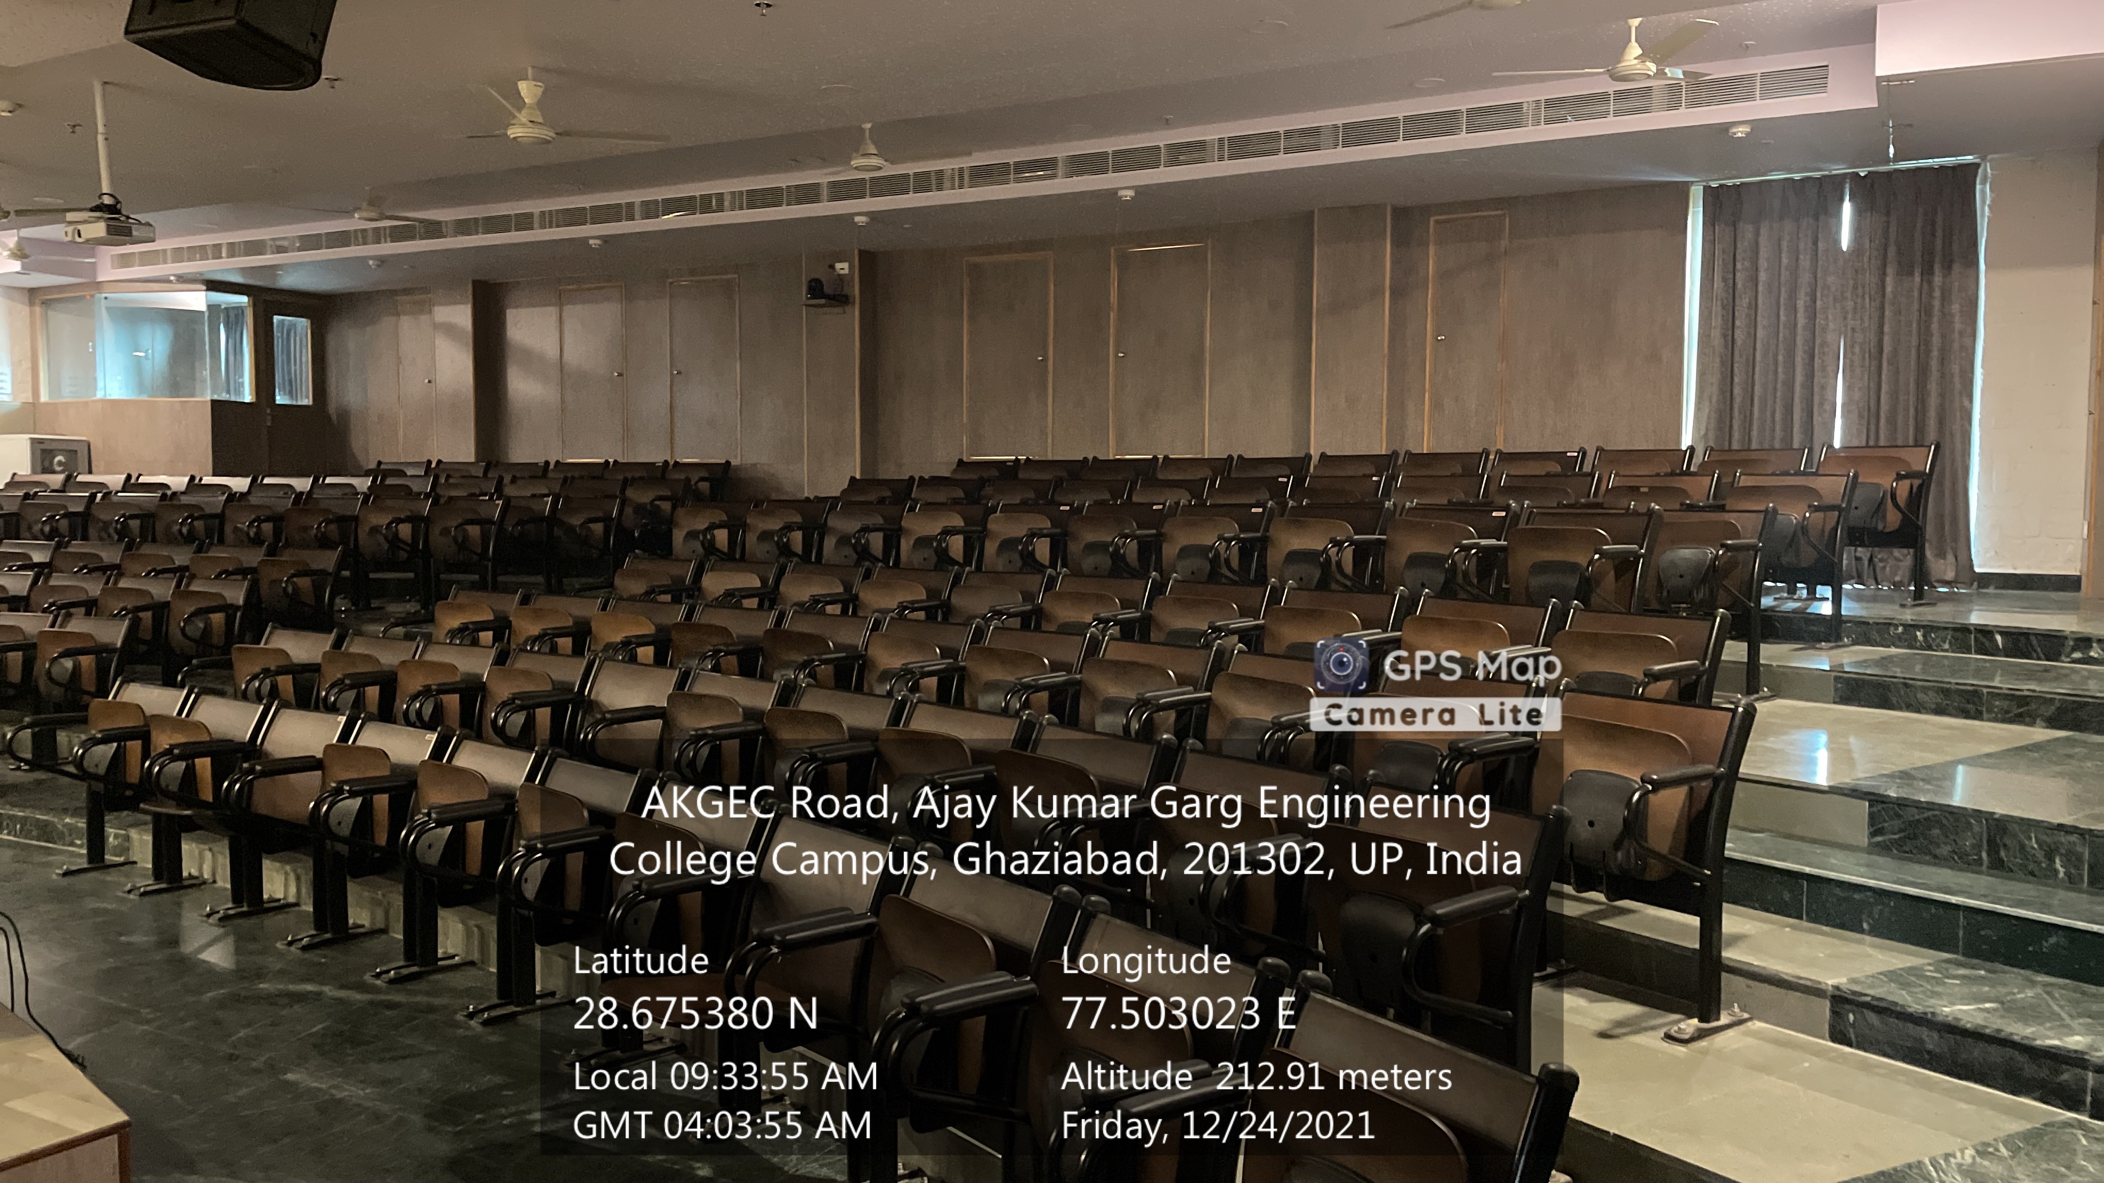

CSIT Auditorium

(CSIT BLOCK, First Floor)

Facilities: (Smart Board, Sound System, Wi-Fi, LAN, White Board)